SPRING ZONE 2018
HOSTED BY LANDMARK KINSMEN
APRIL 21ST , 2018 10:00 AM
LANDMARK, MB

O CANADA

O Canada!
Our home and native land!
True patriot love in all thy sons command. With glowing hearts we see thee rise, The True North strong and free!
From far and wide,
O Canada, we stand on guard for thee. God keep our land glorious and free!
O Canada, we stand on guard for thee Oh Canada, we stand on guard for thee.

Kin Grace

Happy to meet. Sorry to part.
Happy to meet again.
May the Lord make us true Kin
In our thoughts and deeds
And make us truly grateful
For the Food we receive.
Amen

Kin Song

Here we are together once again
One and all a happy bunch of Kin,
Leave your cares and troubles for awhile, let your face break out and smile.
Look around garb someone by the hand, They’re your friends the finest in the land, Now all set, let’s shout to beat the band, Kinsmen, Kinette and Kin!

The Objects of the Association are:

To promote and direct service work through fellowship amongst its members, to the end that:

- They may enjoy personal development through Kin;

- They may be improved and educated in modern business and professional methods and ethics;

- The involvement of each in the enrichment of their community may be stimulated;

- A spirit of co-operation, tolerance, understanding and equality among all nations and peoples be fostered and that unity of thought and purpose throughout Canada be established toward this goal; and

- They shall serve their community’s greatest need.

Fellow Kin, District Leaders, Club Delegates;

The National Board of Directors extends a sincere welcome to everyone attending your Zone meetings today. This is an opportunity for you to move your Zone forward under the leadership of your Deputy Governor and share ideas and plans to continue your successes. It is the perfect time to catch up on what has been happening in the zone and district, and to get a glimpse of what is happening nationally as it impacts everyone locally.

The following updates ensure our National Policies and Procedures empower the fulfillment of our Strategic Plan.

- Holding of Voting Cards (Section 3.08 National Policies and Procedures of the Association)
- In order to ensure the complete integrity of the voting process, the Rules of Order Chair and the Chair of the Conference are not entitled to hold a voting card at any Conference of the Association.
- NEW: The Chair of any meeting is not eligible to hold accredited delegate status to cast votes as they are in a position of influence over the members. They would still act as decision maker in the event of a tie (for which the convention is to vote down the motion). For Example:
At a National Convention, the National President cannot be an Accredited Delegate.
At a District Convention, the Governor would not carry any club votes.
At future Zone meetings, the Deputy Governor would not hold a voting card.

- Conduct, Character, and Community Standing (Section 11 National Policy and Procedures of the Association)
- Updated January 2018; now under review as it pertains to the new Kin Canada’s Screening Requirements Policy
NEW Policy - Kin Canada’s Screening Requirements
Our requirements for screening new members and members in some club leadership positions will be changing as of July 1, 2018.

Why?
- Screening is not a new concept for Kin Canada. To date, screening has included a New Member Application Form, an interview, references or a sponsor.
- Screening is a proactive approach to reducing the risk of situations that could negatively impact your club’s reputation in your community.
- Collectively, we all have a role to play to keep fellow Kin, volunteers, and vulnerable members of our communities safe during service and fellowship initiatives.
- From time-to-time external events impact our business practices and insurance requirements. Due diligence to these matters mitigates risk to physical safety, the privacy of personal information and club assets.
- Ensuring we have robust and affordable insurance is in the best interest of the clubs and the Association.

Next Steps
- The Board and Operations are working together to ensure there are clear policies and procedures in place to serve the Clubs and provide a smooth implementation.
- Topics of consideration:
- Development of standard for membership in The Association of Kin Canada
- Administration of the policy
- Privacy of the information protection
- Costs involved to association and members for screening requirements
- We will keep our members up to date on the progress of this Policy Development plan through regular communication.

We express gratitude to each Governor, District Executive, and Deputy Governor. Leadership is not a position or title, it is action and example; thank you for inspiring your Districts through your confidence, compassion, courage, and commitment to Kin.

The National Board of Directors, Kin Canada

National President Terri – terri.maccannell@gmail.com

A message from Governor Dave:
Fellow Kin,
We are now heading into the final stretch of our Kin Year. Our District was very fortunate this year as each Zone had an outstanding Deputy Governor. All were very engaged in not only what was going on in their Zone but also at the District level. I am sure that their Spring Zone agenda will cover a variety of topics and with these will come some debate as well as the sharing of ideas. You will also have some resolutions to discuss, including any resolutions that come out of your Spring Zone meeting. All motions will be carried forward to District Convention in Kenora, Ontario on June 1st and 2nd. It is okay to have some complaints at the meeting but also come with solutions and suggestions.
Our District Council (mainly David Harmon) has been hard at work this year doing an overhaul on our D2 Awards package. There are several reasons that we did this such as some of the old rules refer to National’s rules when National no longer has that specific award and some were not in a format that made it easy to understand and apply for. This new format follows the same format National is using for all their awards so it will be easier for clubs and members to follow along and keep track. Please take time to review it.
One award that you can tackle at your Spring Zone meeting is Public Speaking. All that you have to do is give a 5-7 minute speech on a topic of your choice and how it connects you to Kin. The journey starts in your club and might end at National Convention in Sarnia in August. Our District will send two of our members to compete. There is no reason why you should not be one of them.
Our District membership is up quite a bit since we welcomed two new clubs into our District. The Treherne Kinettes were chartered in November and The Pas Kinettes were chartered in February. With these two clubs came 44 new members to our family. Most of our Zones showed some growth so I would expect our numbers to be pretty good by the end of the year.
As mentioned above our District Convention will be held at the beginning of June in Kenora. The Kenora Kinsmen club will put on a good show “Under the Big Top”. The location is central
in our District so I ask all members to give consideration to attending. Remember your voice cannot be heard if you do not attend.
I look forward to seeing you in the future at a Spring Zone Meeting or at District Convention. Enjoy yourself, learn lots but most importantly have fun. When the meeting is over have a safe journey home.
Yours in Kin,
Dave Roberts
Governor, District 2
govdaved2@gmail.com

Service Director Report
Congratulations to our newest Kinette Clubs in District 2- the Kinette Clubs of Treherne and The Pas. There clubs are very enthusiastic and have been very busy in their communities. I was able to get out to Treherne for their “Tight and Bright” curling event. I understand there was a lot more enthusiasum Friday night but congrats on the well-run event. The pictures from The Pas were great and extra special to have National President Terri- present.
Our goal for Blood Donors for this year is 150 units- the same as last year- only one other district has a higher goal!! Let’s keep up the great work and remember our donor number is KINC 010789
For KINdness Day 14 Clubs in D2 signed on with National (3 Kin clubs, 3 Kinsmen clubs and 8 Kinette clubs) I am sure that other clubs participated as well. Be sure to let National know what you have done and send pictures!
Don’t forget to put HREF into your budget for the year. You can run a project or just send in a monetary donation. It does not matter the amount- all donations help. Last year 52 students across Canada received $1000 with four of those coming from D2. The number of bursaries given out depends on the amount of the donations from the year before.
The gains make in Cystic Fibrosis research has made a huge impact for those people living with CF and they are truly grateful for the support of Kin Canada. Please continue to support CF with your fundraising. The CF walk is May 27th and you can support our Kin team- Canada (Virtual)-
Kin- At your Service!
Yours in Kin
Pat Moldowan
District 2 Service Director
moldowal@mymts.net

AGENDA

Call to order:

O Canada
Kin Song
Objects of the Association

Moment of Silence for Departed Kin Appointment of Officers:

• Rules of Order
• Secretary
• Sergeant-At-Arms

Address to the chair

Introductions of District Executive
Recognition of past district members
First Timers

Roll Call

Total delegates
Clubs represented

Approval of Agenda
Approval of minutes from Spring Zone 2017
First Call for nominations
Deputy Governor 2019

Spring Zone Host 2019 - OakBank Kinsmen

Reports
Old business/ Business Arising
New Business
2nd Call for Nominations
Deputy Governor

Public speaking Competition/ Joke Off

Resolutions-
• Zone-2

District-2
• Number 1
• Number 2
• Number 3
• Number 4:

3rd call for Nominations:
Deputy Governor:

Zone 2 Joke off

Awards Public Speaker’s Competition Announcements

Good of Kin

Comments by the Host Committee Sergeant-at-Arms

Motion to Adjourn:

D2 Spring Zone 2 Meeting Minutes April 23, 2017

Call to Order: by Governor Art at 11:09 am.

O Canada: led by Larry Markusson, Gimli Kinsmen

Kin Song: led by Jenny Sexton, Gimli Kinettes

Moment of Silence for Departed Kin

Appointment of Officers:

- Rules of Order: Tracy Seib, Gimli Kinettes
- Secretary: Alita Lumgair, Stonewall Kinettes
- Sergeant-At-Arms: Dianne Campbell, Gimli Kinettes
Address to the Chair: Welcome to Gimli

Objects of the Association: Read by Tracy Seib, Gimli Kinettes

Introductions: Dave Roberts, Vice Governor representing John DeBeer, Mike Roberts, Co-Chair
District Convention 2017, Incoming Service Director Pat Moldowan

Recognition of past and present District and Zone Officers

Roll Call

Clubs in Attendance

- All Saints Kinsmen 4
- Gimli Kinettes 8
- Gimli Kinsmen 5
- Landmark & Area Kinsmen 0
- Oakbank-Springfield Kinettes 0
- Oakbank-Springfield Kinsmen 0
- Stonewall Kinettes 10
- Stonewall Kinsmen 0
- Winnipeg Kinsmen 2
Total Delegates in attendance 29

Welcoming Remarks
- Art O’Donnell - This is his first time to hold a position like this in a Service Club. He is interested to see what all the clubs do and he wanted to share the successes with all members.

  - Tracey Seib and Doug Montain – Welcomed everyone to Gimli and thanked their clubs
for their hard work to host Spring Zone 2017, they hope everyone enjoys themselves.

Approval of Agenda: Moved by Colin Edwards, Winnipeg Kinsmen, Seconded by Pam Norquay, Stonewall Kinettes that the agenda be approved. Carried.

Minutes of Previous Zone Conference: Moved by Paul Mudry, All Saints Kinsmen, Seconded by Colin Edwards, Winnipeg Kinsmen that the minutes of Spring Zone 2016 be approved as published in the brochure. Carried.

Nominations 1st call
- Deputy Governor 2017- 2018 - none
Governor’s Report: published in the brochure

Deputy Governor’s Report: published in the brochure

President’s Reports: published in the brochure

Moved by Paul Mudry, Winnipeg Kinsmen, Seconded by Guy Madill, Winnipeg Kinsmen that we approve all reports as printed. Carried.

2nd Call for Nominations:
- Deputy Governor 2017-2018 Colin Edwards, Winnipeg Kinsmen nominated Pam Norquay, Stonewall Kinettes. Pam respectfully declined the nomination.
Old Business: none

Business Arising: none

Resolutions:

- District Resolutions
- Notice of Motion 1 to change Article 4 Sections 1, 3 and Article 5 sections 1,3 that “Directors not to exceed three (3)” to Directors not to exceed five(5)” the rationale is to add a Social Media Director in 2017-18 and an Education/Awards Director in 2018-19 or as Kin education programming becomes more available. Carried.

- Notice of Motion 2 to change the criteria for the Kinette Travelling Trophy. The intent is to provide an equal opportunity for all Kinette clubs in the District to try and achieve this Award as well as align the wording with the District 2 House Rules now that there is single leadership and joint Fall Leadership Conferences and Spring Zones. Carried.

- Notice of Motion 3 Voting regulations have changed on how national directors are elected, changing from a District Election to a National Election so they would like to remove Section 2 of the District House Rules. Carried.

- Notice of Motion 4 Amend Section 3 General Reserve Fund, Article 2 be amended to read. The purpose of the reserve fund shall be to offset unforeseen deficits, excessive dues increases and to assist Clubs in chartering or re-chartering into the Association (see 3.3d for guidelines), and “membership attendance at convention” (see 3.3f for guidelines. The intent is to assist clubs in sending members to conventions which promotes fellowship, develops personal growth and builds clubs by financially assisting one member from non-attending clubs to attend District Convention. The club would qualify if representation has not been sent for 5 years. Assistance would include registration and hotel accommodation at the host hotel for one member. Carried

3rd Call for Nominations

- Deputy Governor 2017-2018 – Colin Edwards, Winnipeg Kinsmen nominated Tracy Seib,
Gimli Kinettes. Art volunteered to be DG again next year but asked for a 15 minutes to discuss it with Tracey and for her to think about it. Colin EdwardS called for a 15 minute bar break. The meeting resumed and Art and Tracey had agreed that Art will be DG for 2017-2018 and she will be DG for 2018-2019. All were in agreement and this was Carried.

Call for motion that nominations for DG’s close: Moved by Guy Madill, Winnipeg Kinsmen that nominations cease and all ballots be destroyed, Seconded by Colin Edwards, Winnipeg Kinsmen. Carried.

Elections and Appointments
- Deputy Governor: Art O’Donnell

Confirmation of Host for Spring Zone 2018: Landmark Kinsmen

Zone 2 Joke off: no jokes

Speaker’s Competition: Vicki Kendall, Stonewall Kinettes. Her speech was “Make it Count” and she will be moving on to the District Speaker’s Competition.

New Business: Gary Fedorchuk introduced Gord Jacobsen, Gimli Kinsmen as the newest Life Member in the Association.

Awards: Travel Award – Stonewall Kinettes
Attendance Award – Stonewall Kinettes

Announcements: Vice Gov. Dave Roberts gave District updates

- we have lost the Winnipeg and Minnedosa Kinettes and have gained the North of 56 Club which has 27 members and growing. The town of Leaf Rapids have given them the Legion building.
-the next census should have D2 in a plus membership.
-Social Media –he encouraged us all to check out the new D2 webpage and let them know what else we would like to see posted there. Please look at the Facebook page and add to it when you have events to announce. There is also a National Facebook page for us to log in and check out.
-Gov John DeBeer is at another Zone Meeting today. He talked about “the Power of One” where everyone should step up and be the one to take the next step forward, become involved as everyone’s vote/opinion matter.

-Dave thanked everyone for the invitation to come today.

D2 Convention at The Pas –Dave and Mike Roberts (co-chair) invited us all to Convention June 1 – 3 which will have a Trapper’s Festival theme. Costume contest is Friday night. They will have fishing, golf and a horseshoe tournament. The Anderson is the Headquarters hotel. There will be shuttle vans for transportation to the meetings at the Legion. If you go to The Pas Convention.ca you can see a video of the Convention.

Convention registration forms are on The Pas Kinsmen website. A bus will be coming from the south. The CF Luncheon will feature a young man from the 2012 convention who is coming back to update us. He also announced that The Pas Kinsmen will pay for 1 member of a club who has not attended before.

Good of Kin: Guy Madill, Winnipeg Kinsmen spoke of his first year as DG and showed a picture of him receiving the Keith Large Outstanding DG Award. He spoke about his bicycle fundraisers and presented a plaque to the Gimli Clubs for supporting him. He has another fundraiser on Apr. 26 at Rumors Comedy Club for Brain Cancer research. Winnipeg Kinsmen will match what is raised. Please pledge to support Guy.

Colin Edwards needs our help in connecting with students at the University of Manitoba to set up a U of MB Campus Club. If we know of any students attending this university He would like to have contact information for them. Please pass this along at upcoming meetings.

Pat Moldowan said that the Milk for Britain Video was nominated at the Chatham Film Festival and it won 2 awards.

Sergeant-at-Arms: Fines were levied. Moved by Debbie Graham, Gimli, Seconded by Pam Norquay, Stonewall that everyone present give a loonie. Carried. A total of $38.70 will be given to Cystic Fibrosis.

Motion to Adjourn: Thorsten Hinz, All Saints Kinsmen moved we adjourn at 1:07 pm.

Motion #1

Notice of Motion by Gord Patterson, Gladstone Kinsmen Club

Whereas: D2 currently recognizes and Outstanding Deputy Governor as the recipient as the winner [sic] of the Keith Large/Catherine Newham award;

And Whereas: Zone participation is the biggest factor in the DG receiving this prestigious award;

Therefore be it resolved: That the Keith Large/ Catherine Newham Outstanding Deputy Governor Award to be renamed the Keith Large/Catherine Newham Outstanding Zone Award.
Intent: To give recognition to the Zone for their efforts in helping in the DG in their job. By doing this, we will be bringing out District in line with National. ( Slight change from original motion presented per telephone discussion between Diane Therian and Gord Patterson October 31/17)

Motion #2

Notice of Motion by Lindsay McDonald (Boissevain Kinette Club)

Whereas the District has been advised by National Headquarters that the term “District Membership Director” has become redundant and has been replaced with “District Club Support Director”

And whereas: The job description for Club Support Director is different than that of Membership Director; Therefore be it resolved: That the District 2 House Rules be amended as follows:

Article 4, Section1.4 and all mention of District Membership Director be amended to read Club Support Director; Article 5, Section 3.4 be deleted and replaced with the District Club Support Director job description

Article 7, Section 1 (Zone Membership Director) be amended to parallel the aforementioned changes.

Intent: To align District 2 House Rules with current National procedures.

Motion #3

Notice of Motion By Bert Baxter (Thunder Bay Hill City, Kinsmen)

Whereas: There are presently two District Governor’s banners; one for the Kinsmen Governor and one for the Kinette Governor;

And Whereas; The current banners are out of date;

Therefore be it resolved: That the District purchase one new banner with the title “Home of the District Governor” and further that the new banner be updated with new patches from where the old banners left off. For the update, where there are two Governors, the banner will have one patch with both names on the patch. Moving forward when there are co-District Governors, they will decide between themselves who will take possession of the banner and for how long during their year.
Intent: To update the District Governor banner and to move away from the designation of “Kinsmen or Kinette District Governor” to embrace the term Kin District Governor.

Motion #4

Notice of Motion by Pat Moldowan (Stonewall Kinette Club)

Whereas: Currently the position of District Membership Director is an elected position;

And Whereas: Should Motion #2 above be accepted and approved by the membership, there will no longer be a District Membership Director and there will be a District Club Support Director with a different job description;

And Whereas: all other positions in the District Executive are appointed by the District Governor(s) of the day; Therefore be it Resolved: That the District 2 house rules be amended as follows:
Article 6, Section 3 be deleted;
Article 5, Section 4 be amended to read “Five (5) Directors shall be appointed/selected by the Vice-Governors as they form their team.
Intent: To align the process of selection of District Club Support Director with that of other District Directors.

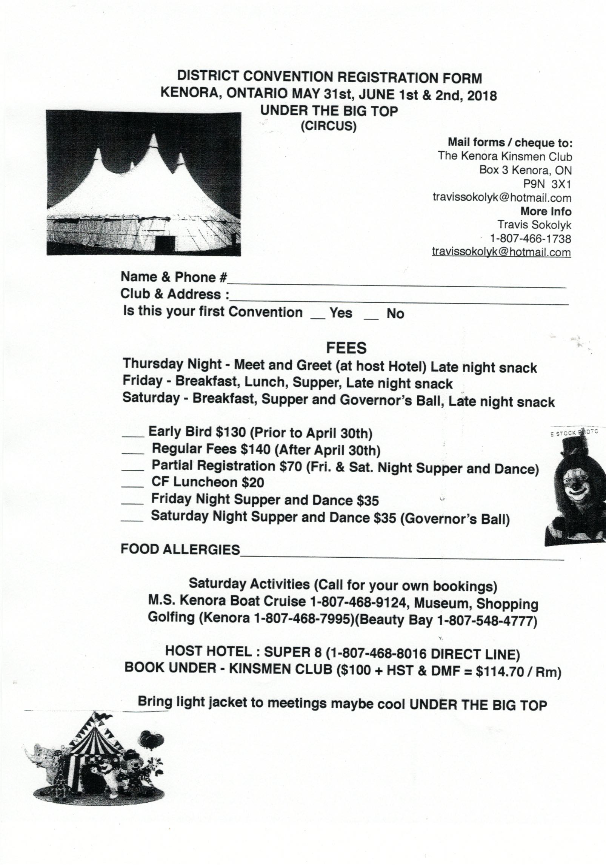

Forms are due by: *** |  |  | FAILURE TO SUBMIT A COMPLETED FORM BY
THE DEADLINE MEANS YOUR CLUB IS UNABLE TO VOTE AT SPRING ZONE 2018.
(Please √ one) |  | ☐ Kinsmen | ☐ Kinette |  |  | ☐ Kin Club
(Please print clearly) |  | Club of |  |  |  |  | Zone
ALL CLUBS, whether you are attending or not, MUST completely fill out this form in order to
exercise your vote. Forms are invalid if not fully filled in (boxes checked).

ACCREDITED DELEGATE:
Name: |  |  |  | Club:
ALTERNATE ACCREDITED DELEGATE(S): in order of ranking (Optional)
- Name: |  |  |  | Club:
- Name: |  |  |  | Club:
If AD or AAD’s are not from the Club being represented:
☐ | Have the delegates listed above agreed to take on the AD or AAD role for your club?
☐ | Does your club understand that the delegates listed above may hold other club votes and may not hold your club vote in a flash card vote?
☐ | Has your club given voting instructions to the delegates listed above?
CLUB CERTIFICATION:
We, the underside (2 of the following positions – President, Vice-President, Secretary) of the above named club, hereby certify that our club, at a regularly constituted meeting held on
_____________________ (insert date) has voted to appoint the people named above as our Accredited Delegate and Alternate Accredited Delegate(s):
Club Position: |  |  | Club Position:
Signature: |  |  | Signature:
Name: (Print) |  |  | Name: (Print)
Date: |  |  | Date:
SUBMISSION INFORMATION:
Can be scanned and emailed to: ***
Can be faxed to: ***
Can be mailed to: ***

SUBMMISSION DEADLINE IS MIDNIGHT, ***

District 2 Convention Bus Trip 2018

Destination, Kenora Ontario

When May 31st- June 2nd

Governor Dave is looking into cost and how many of us Kinfolk are interested in travelling in style.

More information to come!!!!






